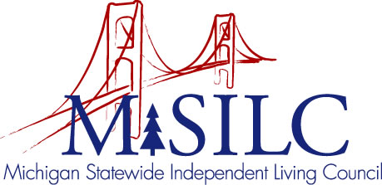

OPEN MEETINGS NOTICE
OUR VISION

To Champion systemic change creating inclusive communities across the state for all Michigan citizens.

SPIL MISSION

To promote independent living opportunities across all spheres of life.

The SILC Membership
is pleased to announce their upcoming
Business Meeting

December 17, 2020
Zoom Teleconference Meeting

Quarterly Business Meeting: 5:30 p.m. - 6:00 p.m.

Call In: 1-646-558-8656
Access Code: 863 9678 1573
Password: 773984

