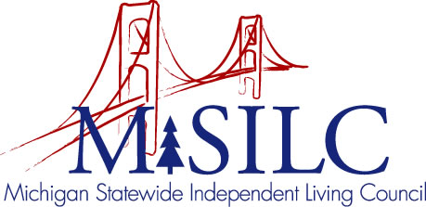

OPEN MEETINGS NOTICE

OUR VISION
People with disabilities are valued; their rights are undeniable and inherent in all aspects of life.

SPIL MISSION
People with disabilities advocating for inclusion, equity, and accessibility in all communities.

The SILC Membership
is pleased to announce their upcoming
Business Meeting

September 8, 2023
Disability Network Southwest Michigan, 517 E. Crosstown Parkway, Kalamazoo MI, and Zoom Teleconference Meeting

Quarterly Business Meeting: 12:00 p.m.

Call In: 1-646-558-8656
Meeting ID: 874 5817 1531

Join Zoom Meeting
https://us02web.zoom.us/j/87458171531

NOTE: To be responsible stewards of public funds, we ask that if you plan to join us for lunch, you contact our staff at: 833.808.7452 – toll free

NOTE: If you need reasonable accommodations to participate in this meeting, please contact our office no later than Friday, September, 2023.

