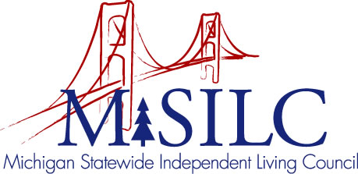

OPEN MEETINGS NOTICE

OUR VISION
People with disabilities are valued; their rights are undeniable and inherent in all aspects of life.

SPIL MISSION
People with disabilities advocating for inclusion, equity, and accessibility in all communities.

The SILC Membership
is pleased to announce their upcoming
Business Meeting

September 14, 2022
Zoom Teleconference Meeting

Quarterly Business Meeting: 5:30 p.m. - 8:30 p.m.

Call In: 1-646-558-8656
Meeting ID: 850 5482 3073

Join Zoom Meeting
https://us02web.zoom.us/j/85054823073

NOTE: To be responsible stewards of public funds, we ask that if you plan to join us for lunch, you contact our staff at: 833.808.7452 – toll free

NOTE: If you need reasonable accommodations to participate in this meeting, please contact our office no later than Wednesday, September 7, 2022.

