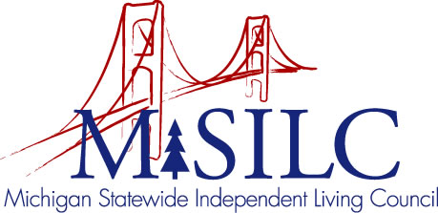

OPEN MEETINGS NOTICE

OUR VISION
People with disabilities are valued; their rights are undeniable and inherent in all aspects of life.

SPIL MISSION
People with disabilities advocating for inclusion, equity, and accessibility in all communities.

The SILC Membership
is pleased to announce their upcoming
Business Meeting

January 13, 2023
Disability Network Capital Area, 901 E. Mt. Hope Avenue, Lansing MI 48910 and
Zoom Teleconference Meeting

Quarterly Business Meeting: 12:00 p.m. - 3:00 p.m.

Call In: 1-646-558-8656
Meeting ID: 895 3156 3597

Join Zoom Meeting
https://us02web.zoom.us/j/89531563597

NOTE: To be responsible stewards of public funds, we ask that if you plan to join us for lunch, you contact our staff at: 833.808.7452 – toll free

NOTE: If you need reasonable accommodations to participate in this meeting, please contact our office no later than Friday, January 6, 2023.

