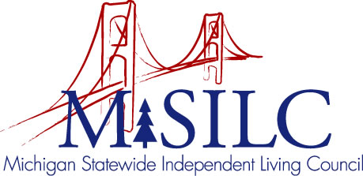

OPEN MEETINGS NOTICE

OUR VISION

People with disabilities are valued; their rights are undeniable and inherent in all aspects of life.

SPIL MISSION

People with disabilities advocating for inclusion, equity, and accessibility in all communities.

The SILC Membership
is pleased to announce their upcoming
SILC Executive Committee Meeting

January 30, 2023
10:00 a.m.
Teleconference

Call In: #1-646-558-8656
Meeting ID: 840 7922 7028

Join Zoom Meeting
https://us02web.zoom.us/j/84079227028

