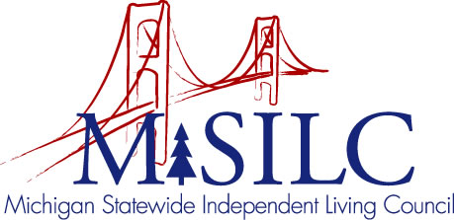

OPEN MEETINGS NOTICE

OUR VISION
People with disabilities are valued; their rights are undeniable and inherent in all aspects of life.

SPIL MISSION
People with disabilities advocating for inclusion, equity, and accessibility in all communities.

The SILC Membership
is pleased to announce their upcoming
SILC Retreat

August 27, 2022
Zoom Teleconference Meeting

Meeting: 10:00 a.m. - 2:00 p.m.

Call In: 1-646-558-8656
Meeting ID: 819 9390 5234

Join Zoom Meeting
https://us02web.zoom.us/j/81993905234

NOTE: If you need reasonable accommodations to participate in this meeting, please contact our office no later than Friday, August 19, 2022.

