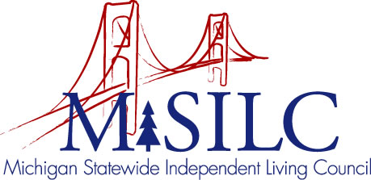

OPEN MEETINGS NOTICE

OUR VISION
People with disabilities are valued; their rights are undeniable and inherent in all aspects of life.

SPIL MISSION
People with disabilities advocating for inclusion, equity, and accessibility in all communities.

The SILC Membership
is pleased to announce their upcoming
SPIL Writing Team Meeting

August 8, 2022
Zoom Teleconference Meeting

5:00 p.m. - 6:00 p.m.

Call In: 1-646-558-8656
Meeting ID: 835 4674 6314

Join Zoom Meeting
https://us02web.zoom.us/j/83546746314

