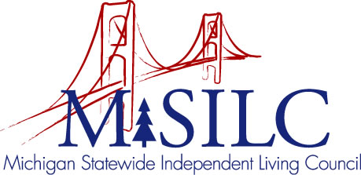

OPEN MEETINGS NOTICE

OUR VISION
People with disabilities are valued; their rights are undeniable and inherent in all aspects of life.

SPIL MISSION
People with disabilities advocating for inclusion, equity, and accessibility in all communities.

The SILC Membership
is pleased to announce their upcoming
Business Meeting

June 9, 2023
Superior Alliance for Independent Living, 1200 Wright St Suite A, Marquette, MI 49855, and Zoom Teleconference Meeting

Quarterly Business Meeting: 12:00 p.m.

Call In: 1-646-558-8656
Meeting ID: 869 3952 1766

Join Zoom Meeting
https://us02web.zoom.us/j/86939521766

NOTE: To be responsible stewards of public funds, we ask that if you plan to join us for lunch, you contact our staff at: 833.808.7452 – toll free

NOTE: If you need reasonable accommodations to participate in this meeting, please contact our office no later than Friday, June 2, 2023.

