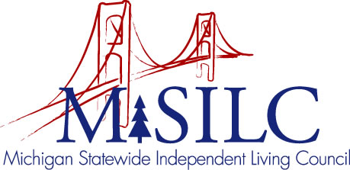

OPEN MEETINGS NOTICE
OUR VISION

To Champion systemic change creating inclusive communities across the state for all Michigan citizens.

SPIL MISSION

To promote independent living opportunities across all spheres of life.

The SILC Membership
is pleased to announce their upcoming
Business Meeting

January 19, 2022
Zoom Teleconference Meeting

Quarterly Business Meeting: 5:30 p.m. - 8:30 p.m.

Call In: 1-646-558-8656
Meeting ID: 873 4374 3842

Join Zoom Meeting
https://us02web.zoom.us/j/87343743842

NOTE: To be responsible stewards of public funds, we ask that if you plan to join us for lunch, you contact our staff at: 833.808.7452 – toll free

NOTE: If you need reasonable accommodations to participate in this meeting, please contact our office no later than Friday, January 14, 2022.

